EXPERIMENT NO 14

Determination and plotting of Polarization in different Dielectric Medium with their relative permittivity and to find electric susceptibility.
Aim:
To determine and plot polarization in different dielectric medium with their relative permittivity and to find electric susceptibility.

Software required:
- SCILAB version 6.0.1

Program:

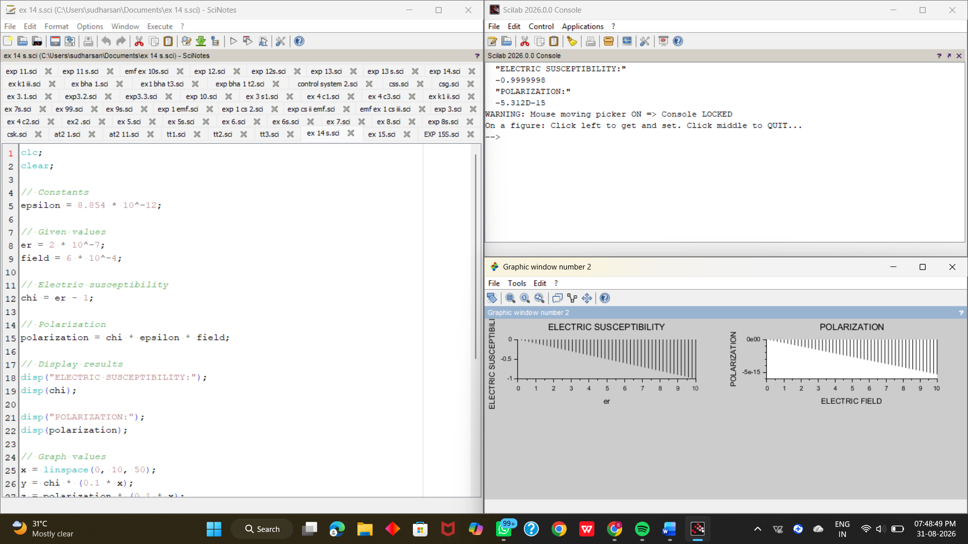

Output:



Theoretical calculations:
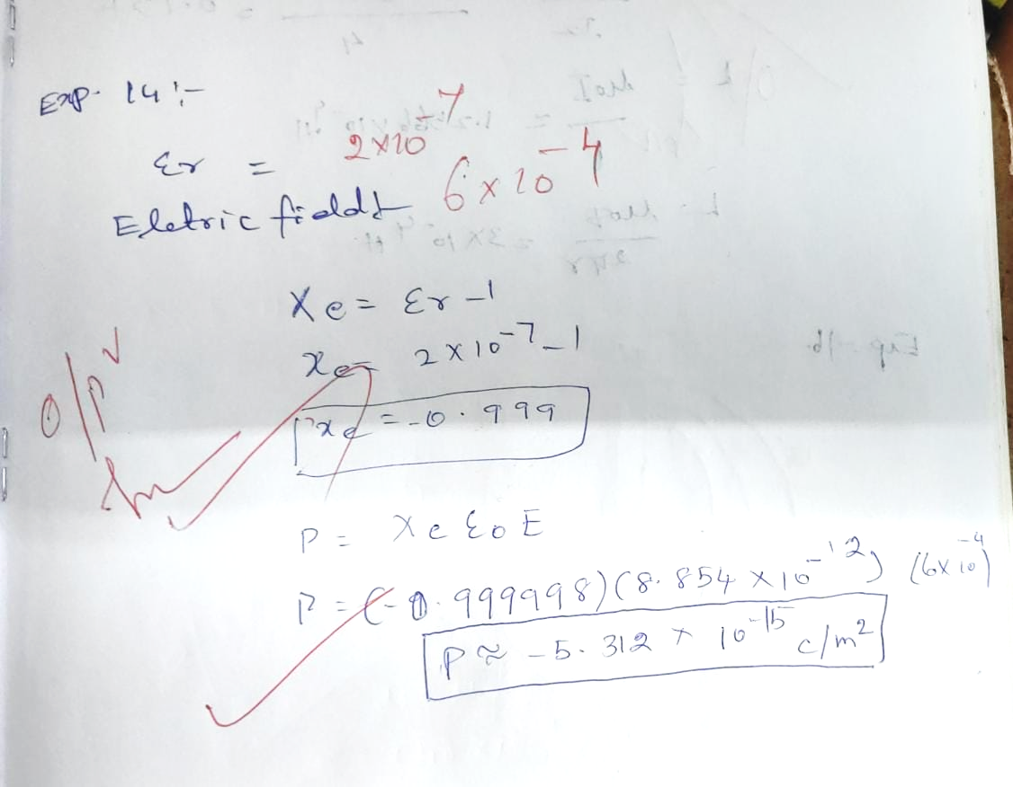

Case 1: To determine and plot the polarization and electric susceptibility of electromagnetic waves in three dielectric media: Air, Water, and Glass, using their relative permittivity.
Program:
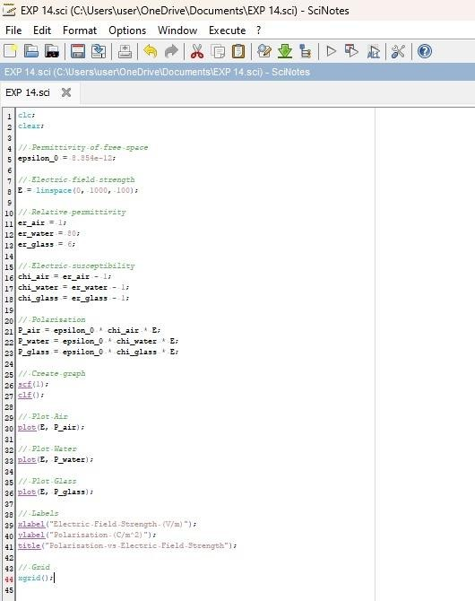

Output:
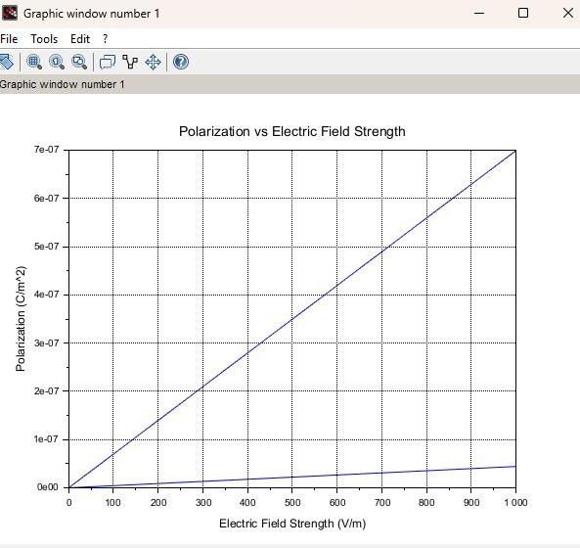
Case 2: To calculate and plot the polarization and electric susceptibility in Silicon, Teflon, and Paper, and understand how their relative permittivity affects the polarization.

Program:
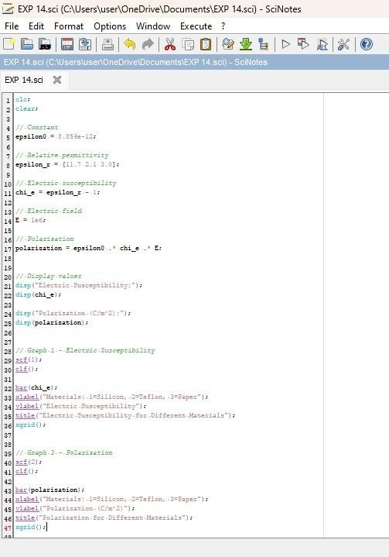

Output:
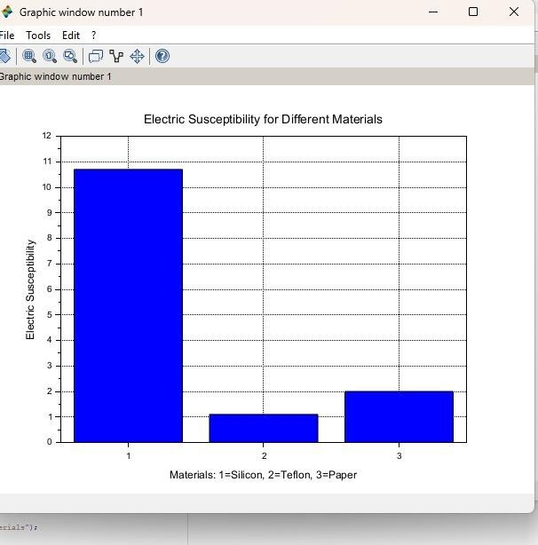
Case 3: To explore how different dielectric materials (Rubber, Oil, and Plastic) affect the polarization and electric susceptibility, and to compare their relative permitivity.

Program:
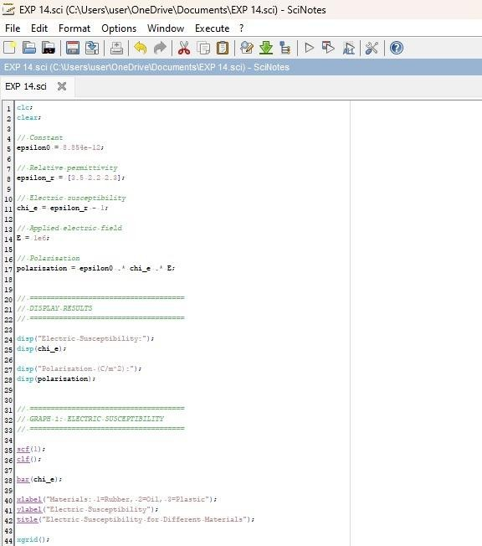
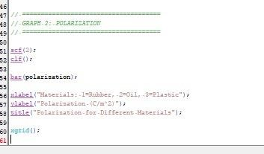

Output:
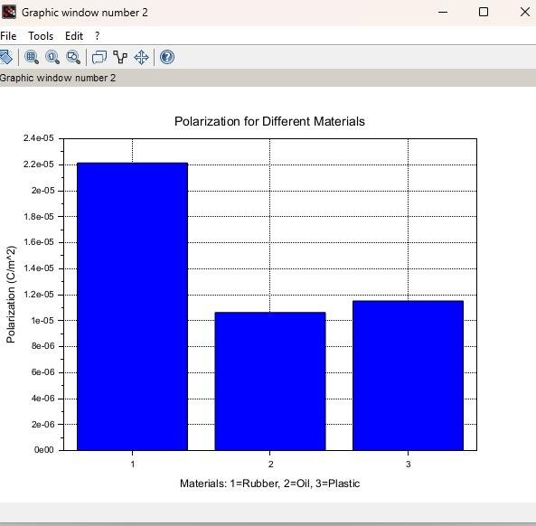

Case 1: Examine the effect of length of a ferromagnetic material on the magnetic flux density (B) for the
following conditions



The material is ferromagnetic with relative permeability (μr) of 500. The magnetic field intensity (H) is held constant at 100 A/m.
The length of the material varies from 0.1 m to 2 m.

Program:

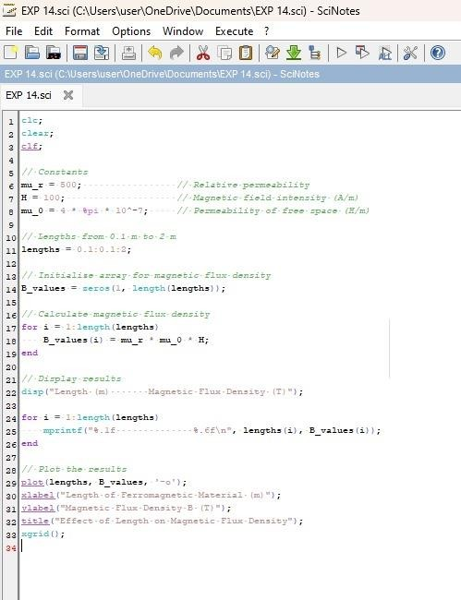

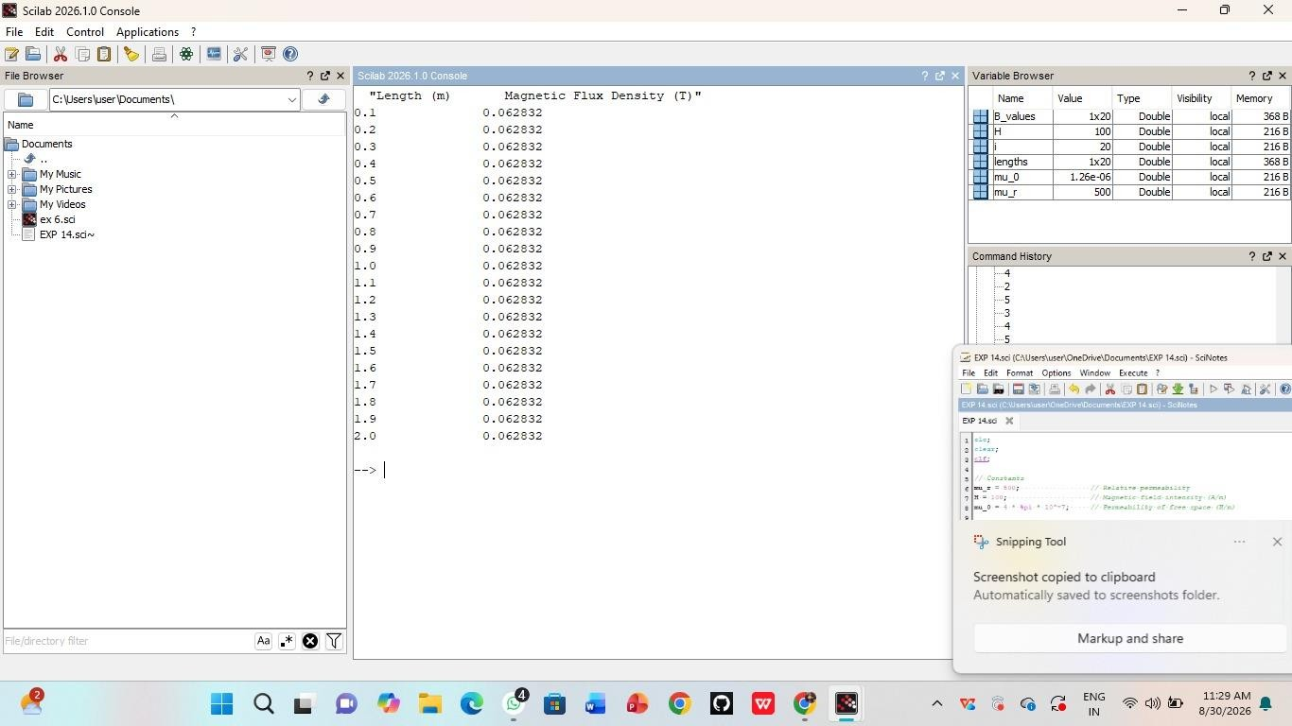
Output:
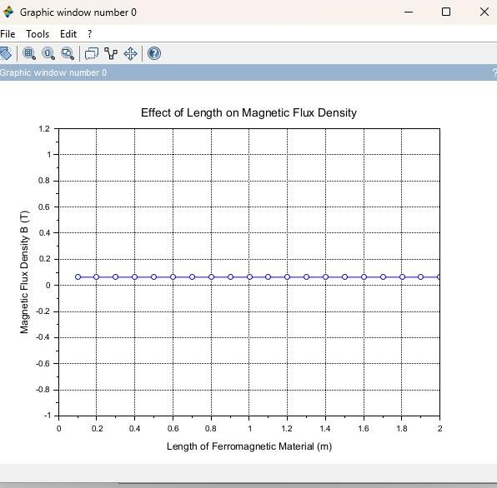

Case 2: To investigate how the magnetic flux density (B) in a ferromagnetic material changes with
different widths at a constant length and magnetic field intensity. Conditions:
- Material: Soft iron (same as in Case Study 1)
- Length (L): Constant at 10 cm
- Magnetic Field Intensity (H): Constant at 1000 A/m
- Width (W): Varies from 2 cm to 10 cm (i.e., 2 cm, 4 cm, 6 cm, 8 cm,
10 cm)

Program:
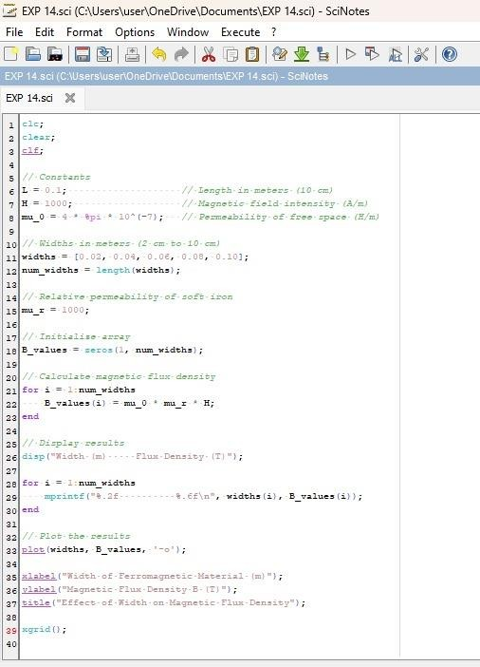

Output:

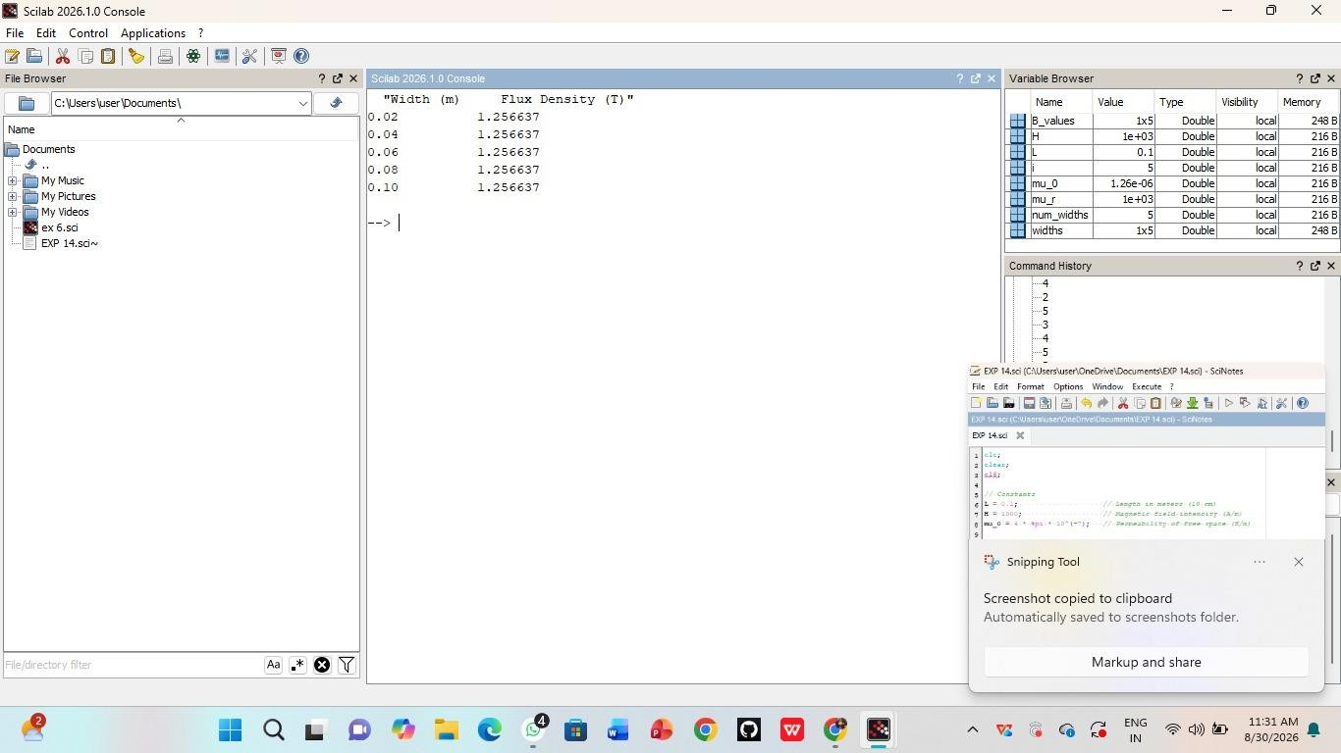
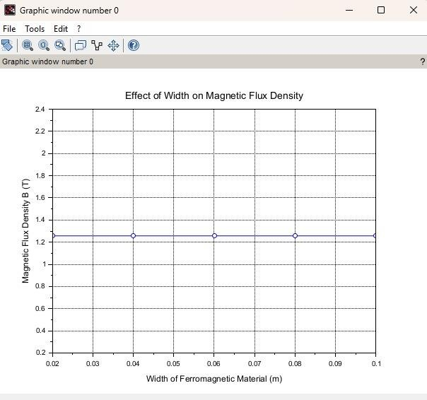

Case 3: To examine how the magnetic flux density (B) in a ferromagnetic material changes with different values of magnetic field intensity at constant length and width.
Conditions:
- Material: Soft iron (same as in the previous studies)
- Length (L): Constant at 10 cm
- Width (W): Constant at 5 cm
- Magnetic Field Intensity (H): Varies from 200 A/m to 2000 A/m (i.e., 200 A/m, 500 A/m, 1000 A/m, 1500 A/m, 2000 A/m)

Program:
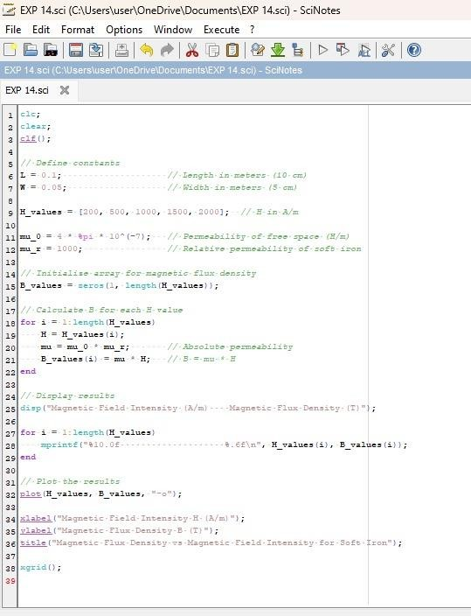

Output:
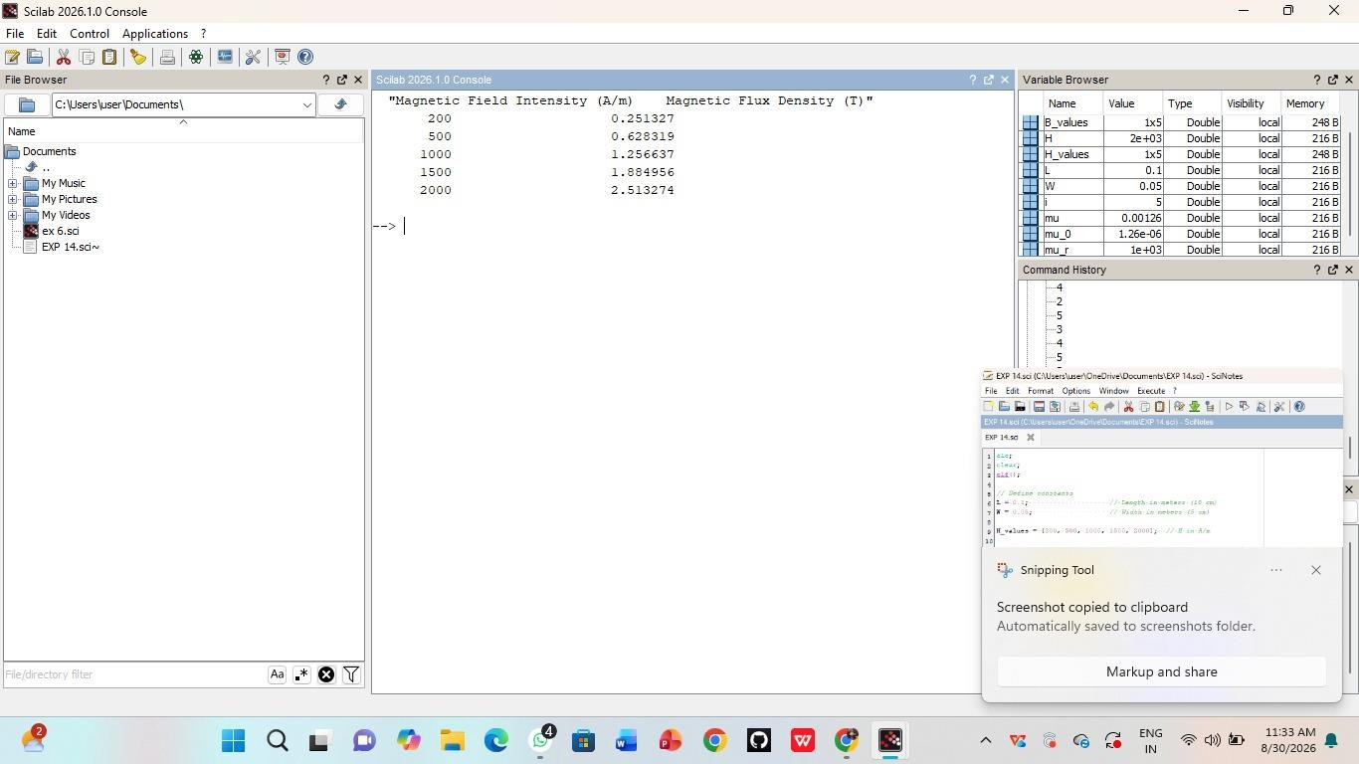

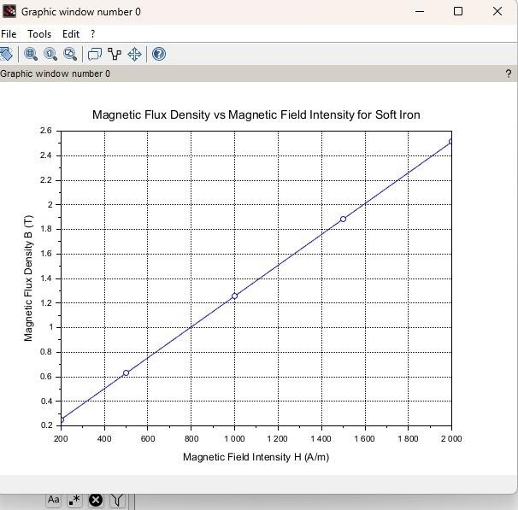

Result : Thus the program was verified for program for Magnetic flux density in ferromagnetic materials using SCILAB was successfully.

